DSA-VT2 Practical

(Used in CodeChef and online GDB in C program compiler)

**NAME: Hardik Chhabra**

**ROLL No.: 2020UEA6504**

**Q. Write a program to implement a double-ended queue using a Linked List**

/*NAME: Hardik Chhabra

ROLL No.: 2020UEA6504

PROGRAM: Write a program to implement a double-ended queue using a Linked List*/

#include <stdio.h>

#include <stdlib.h>

struct dll {

struct dll *left;

int data;

struct dll *right;

};

typedef struct dll node;

node *start = NULL;

node* getnode() {

node * newnode;

newnode = (node *) malloc(sizeof(node));

printf("\n Enter data: ");

scanf("%d", &newnode -> data);

newnode -> left = NULL;

newnode -> right = NULL;

return newnode;

}

int countnode(node *start) {

if(start == NULL) {return 0;}

else {return (1 + countnode(start -> right));}

}

void menu() {

printf("\t MENU");

printf("\n------------------------------");

printf("\n 1.Insertion");

printf("\n------------------------------");

printf("\n 2.Deletion");

printf("\n------------------------------");

printf("\n 3.Traversing (L->R)");

printf("\n------------------------------");

printf("\n 4.Count the Number of nodes in the list");

printf("\n------------------------------");

printf("\n 5.Exit");

printf("\n------------------------------");

}

void insert(int item) {

node *ptr = (node *) malloc(sizeof(node));

node *temp;

if(ptr == NULL) {

printf("\n OVERFLOW!!!");

}else {

ptr->data=item;

if(start == NULL) {

ptr->right = NULL;

ptr->left = NULL;

start = ptr;

}else {

temp = start;

while(temp->right!=NULL) {

temp = temp->right;

}

temp->right = ptr;

ptr ->left=temp;

ptr->right = NULL;

}

printf("\n Node Inserted!!!");

}

}

void deletion() {

node *ptr;

if(start == NULL) {

printf("\n UNDERFLOW!!!");

}else if(start->right == NULL) {

start = NULL;

free(start);

printf("\n Node Deleted!!!\n");

}else {

ptr = start;

start = start -> right;

start -> left = NULL;

free(ptr);

printf("\n Node Deleted!!!\n");

}

}

void traverse() {

node *temp;

temp = start;

printf("\n The contents of List: ");

if(start == NULL )

{printf("\n Empty List");}

else {

while(temp != NULL) {

printf("%d <--> ", temp -> data);

temp = temp -> right;

}

printf("X");

}

}

int main(void) {

int ch,mat;

menu();

while(1) {

printf("\n Enter your choice: ");

scanf("%d", &ch);

switch(ch) {

case 1: printf("\n Enter data: ");

scanf("%d",&mat);

insert(mat);

break;

case 2: deletion();

break;

case 3: traverse();

break;

case 4: printf("\n Number of nodes: %d", countnode(start));

break;

case 5: printf("\n Exit!!!");

exit(0);

}

}

return 0;

}

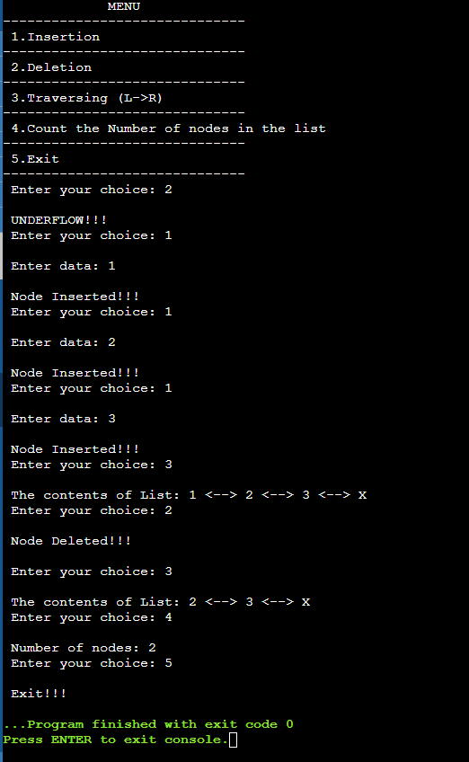**OUTPUT**